Fun with 2D Arrays
Special notes: This problem is worth 11 points.
In this problem you are to complete three methods in the FunWith2Darrays class. The three methods are isArrowHeadArray, isIntegerGeneralizedPermutationArray and the isMongeArray method.

The isArrowHeadArray method has a single int[] [] isArrow parameter and returns a boolean. isArrowHeadArray returns true is the parameter isArrow is an Arrowhead matrix and false if isArrow is not an Arrowhead matrix.

According to Wikipedia: In the mathematical field of linear algebra, an arrowhead matrix is a square matrix containing zeros in all entries except for the first row, first column, and main diagonal. In other words, the matrix has the form

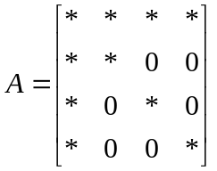

Where * is any non-zero value.

In writing the isArrowHeadArray method, you may assume:
- isArrow[i].length == isArrow[k].length
for all i, k, with 0 <= i, j < isArrow.length
- isArrow.length > 0 && isArrow[0].length > 0

The following table shows the results of two calls of the isArrowHeadArray method.

The following code | Returns
FunWith2DArrays ma = new FunWith2DArrays();  int[][] isArrow = { {0, 0, 0, 0},  {0, 0, 16, 29},  {0, 28, 0, 34},  {0, 13, 6, 0} };  ma.isArrowHeadArray( isArrow ); | false
FunWith2DArrays ma = new FunWith2DArrays();  int[][] isArrow1 = { {10, 11, 12, -3},  {20, -1, 0, 0},  {30, 0, 33, 0},  {40, 0, 0, 9} };  ma.isArrowHeadArray( isArrow1 ); | true

The isIntegerGeneralizedPermutationArray method has a single int[] [] gpa parameter and returns a boolean. isIntegerGeneralizedPermutationArray returns true if the parameter gpa is a Generalized Permutation Matrix (with integer elements) and false if gpa is not a Generalized Permutation Matrix.

According to Wikipedia: In mathematics, a generalized permutation matrix is a matrix with the same nonzero pattern as a permutation matrix, i.e. there is exactly one nonzero entry in each row and each column. Unlike a permutation matrix, where the nonzero entry must be 1, in a generalized permutation matrix the nonzero entry can be any nonzero value. An example of a generalized permutation matrix is
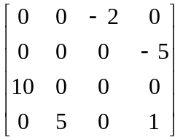

In writing the isIntegerGeneralizedPermutationArray method, you may assume:
- gpa[i].length == gpa{k].length
for all i, k, with 0 <= i, j < gpa.length
- gpa.length > 0 && gpa[0].length > 0

The following code shows the results of a call to the isIntegerGeneralizedPermutationArray method.

The following code | Returns
FunWith2DArrays ma = new FunWith2DArrays();  int[][] isgpm1 = { { 0, 0, -2, 0},  { 0, 0, 0, -5},  {10, 0, 0, 0},  { 0, 5, 0, 0} };  ma.isIntegerGeneralizedPermutationArray( isgpm1 ) ); | true

The isMongeArray method has a single int[] [] ma parameter and returns a boolean. isMongeArray returns true if the parameter ma is a Monge Matrix (with integer elements) and false if ma is not a Monge Matrix.

According to Wikipedia: Monge arrays, or Monge matrices, are mathematical objects named for their discoverer, the French mathematician Gaspard Monge.
An m-by-n matrix is said to be a Monge array if, for all 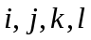 such that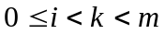 and 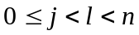 one obtains
So whenever we pick two rows and two columns of a Monge array (a 2 × 2 sub-matrix) and consider the four elements at the intersection points, the sum of the upper-left and lower right elements (across the main diagonal) is less than or equal to the sum of the lower-left and upper-right elements (across the antidiagonal).
This matrix is a Monge array:
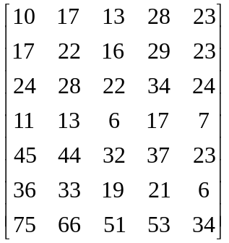

For example, take the intersection of second and fourth row with the first and fifth column. The four elements are:

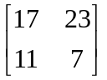
17 + 7 = 24
23 + 11 = 34

The sum of the upper-left and lower right elements is less than or equal to the sum of the lower-left and upper-right elements.

In writing the isMongeArray method, you may assume:
- ma[i].length == ma[k].length
for all i, k, with 0 <= i, j < ma.length
- ma.length > 0 && ma[0].length > 0

Do NOT assume the 2d array is a square array

The following code shows the results of the isMongeArray method.

The following code | Returns
FunWith2DArrays ma = new FunWith2DArrays();  int[][] values = { {10, 17, 13, 28, 23},  {17, 22, 16, 29, 23},  {24, 28, 22, 34, 24},  {11, 13, 6, 17, 7},  {45, 44, 32, 37, 23},  {36, 33, 19, 21, 6},  {75, 66, 51, 53, 34} };  ma.isMongeArray( values ); | true

